**Bank Customer Churn Analysis**

## **INTRODUCTION**

**Description**

Customer churn is a significant concern in the financial industry, as losing customers not only affects revenue but also increases the cost of acquiring new clients. Understanding why customers leave and identifying patterns and trends associated with churn can provide valuable insights to inform targeted retention strategies. This study analyse customer churn data from a financial institution, examining various demographic and financial factors such as credit score, geography, age, tenure, account balance, estimated salary to uncover key insights of churn.

By leveraging this data, we aim to build a comprehensive understanding of churn dynamics and provide actionable recommendations to improve customer retention.

## **About DATASET**

Account information for 10,000 customers at a European bank, including details on the salary, products, credit card (0 0r 1) and whether they have churned or not ( 1 or 0) .

It consists of the customer and account data.

**Tool used**: Power BI ( Power Query and Power Bi Desktop)

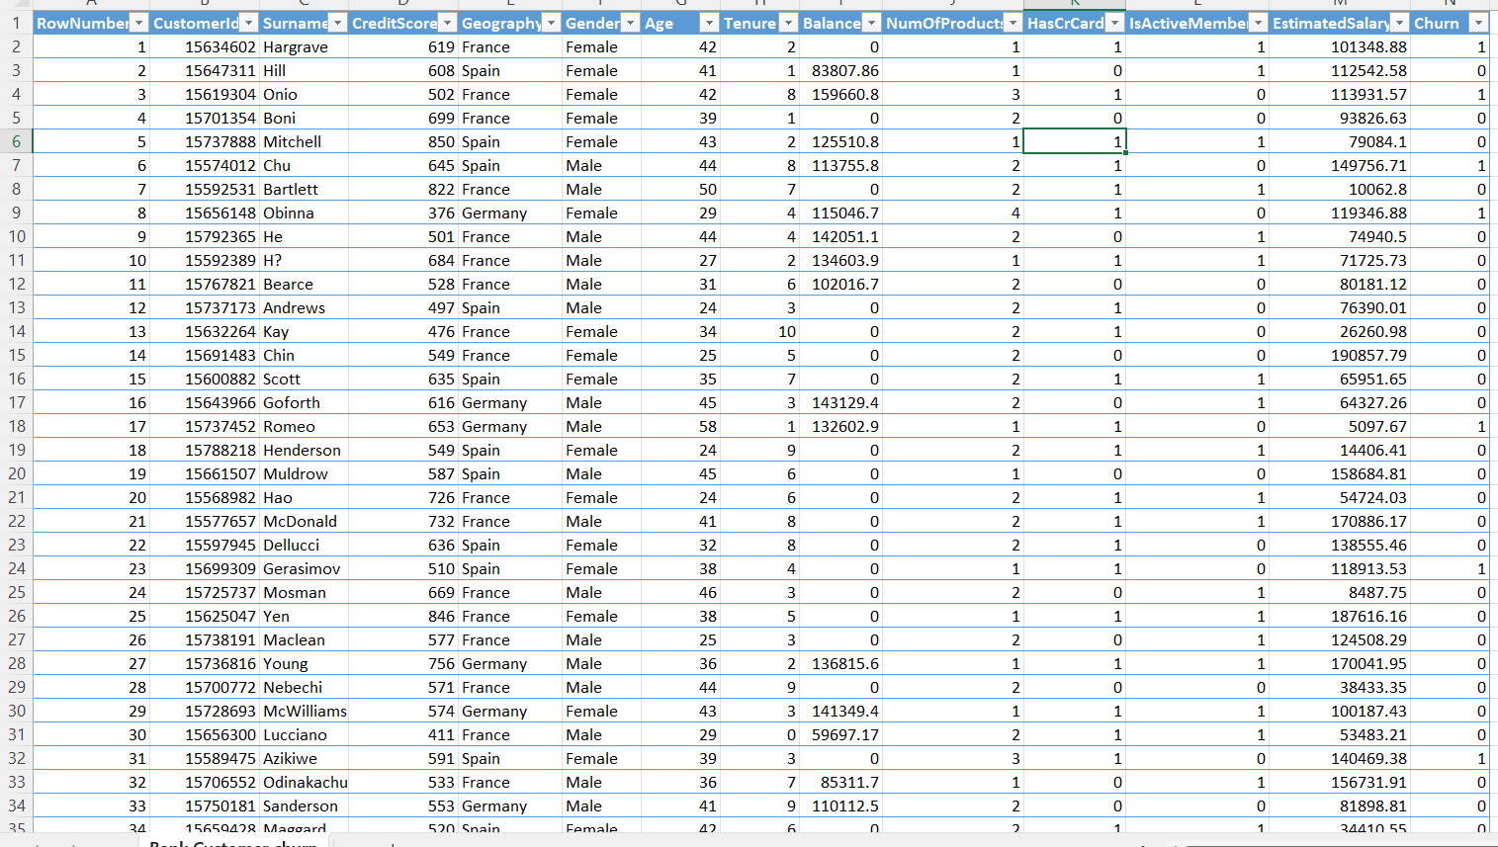

**Data Transformation (Cleaning and Integration):**

* **Check for Missing Values and Duplicate Entries**
* **Remove Duplicate Entries: Ensure there are no duplicate rows in the dataset.**
* **Check for Missing Values: Verify that there are no missing values in any column.**

**Data Type Formatting**

**Ensure all columns have the correct data types (e.g., numerical columns are set to number, text columns are set to text, etc.).**

**Merge Prefix to Product Column**

* **Add Prefix: Merge the prefix “Prod” to the column “Product”, converting values 1, 2, 3, 4 to Prod1, Prod2, Prod3, Prod4 respectively.**
* **Remove Original Column: Remove the initial column for “Product” after merging the prefix.**

**Replace Values in Columns**

* **Churn Column: Replace values in the “Churn” column, changing 1 to “Churned” and 0 to “Not Churned”.**
* **Credit Card Status Column: Replace values in the “Credit Card Status” column, changing 1 to “Owned” and 0 to “Not Owned”.**
* **Activity Status Column: Replace values in the “Activity Status” column, changing 1 to “Active” and 0 to “Inactive”.**

🔑 **Key Steps in the Project:**

* **Data Exploration & Preparation: I merged and cleaned data from multiple sources—customer demographics, transaction history, and service usage—to build a robust foundation for analysis.**
* **Churn Prediction: Using Power BI, I built predictive models using DAX and Power Query to identify high-risk customers and predict churn behaviour.**
* **Data Visualization: Developed dynamic, interactive dashboards in Power BI to visualize key metrics such as churn** **rate, customer segmentation, and service engagement**.

**Dashboards**

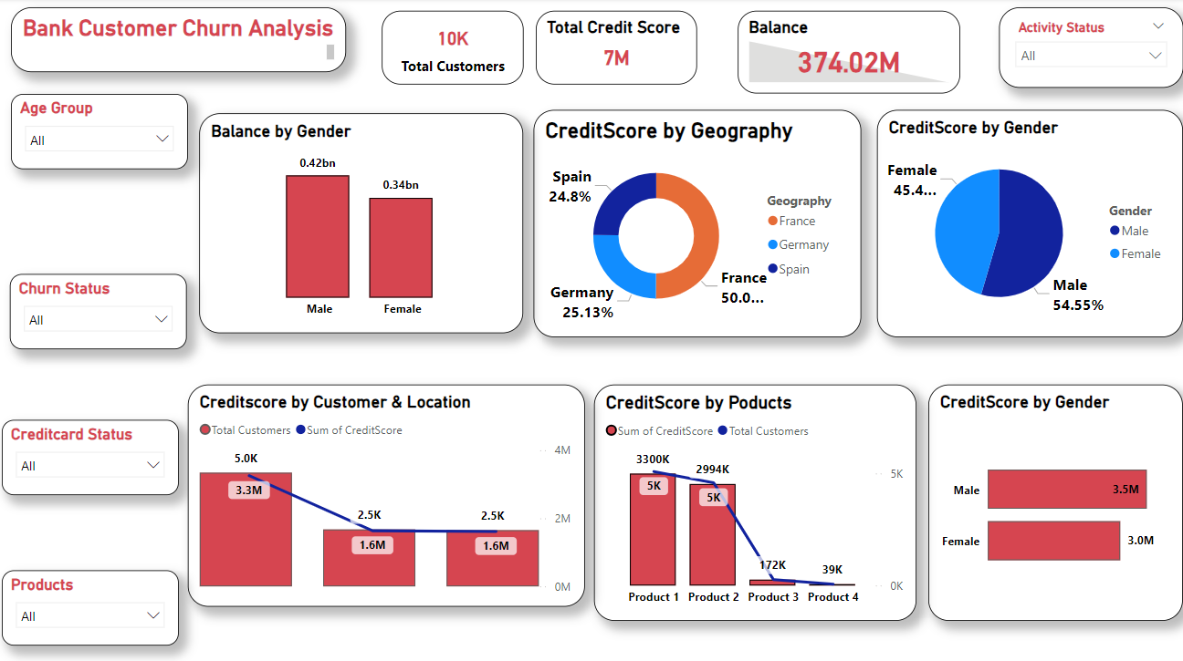

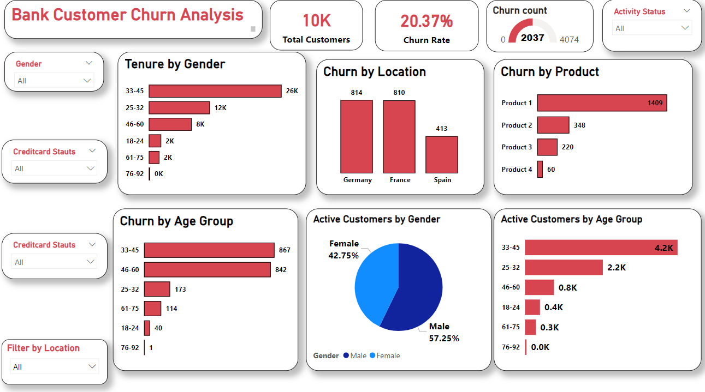

**🔑 Key Insights & Findings :**

* **Total Customers and Churn Rate:**
* **Total Customers: 10,000**
* **Churn Rate: 20.4% (2,037 customers) — significantly higher than the target churn rate of 15%.**
* **Retention: 79.63% of customers are retained, but the churn rate indicates an urgent need for improved retention strategies.**
* **Gender Distribution:**
* **Female: 54.57%, Male: 45.43%**
* **The gender distribution is relatively balanced, suggesting that gender is not a significant factor in churn.**
* **Activity Status:**
* **Active: 51.51%**
* **Inactive: 48.49%  
  With nearly half of customers inactive, this represents a high churn risk. Inactive customers are often more likely to leave, indicating a need for re-engagement campaigns.  
  Credit Card Status:  
  70.55% of customers own a credit card, while 29.45% do not.  
  Credit card ownership is linked to higher customer engagement and loyalty, so addressing the needs of customers without credit cards could help reduce churn.  
  Geographical Distribution:  
  Spain: 24.77%, Germany: 25.09%, France: 50.14%  
  The highest concentration of customers is in France, which presents an opportunity to implement region-specific strategies to combat churn in this area.**
* **Product Distribution:**
* **Product 1: 50.84%, Product 2: 45.9%, Product 3: 2.66%, Product 4: 0.60%  
  There is low adoption of Products 3 and 4, suggesting that further investigation is needed to understand why these products are underperforming and whether they are contributing to customer churn.**
* **Age Group Analysis:**
* **Highest churn rate: The 51–60 age group, with a churn rate of 56.2%.**
* **Lowest churn rate: The Under 20 age group, at 5.6%.  
  The 51–60 age group appears to be experiencing issues prompting them to leave, which could be addressed with targeted retention strategies.**
* **Credit Score Analysis:**
* **Highest churn rate: Credit scores < 400 show a 100% churn rate.  
  Customers with lower credit scores are at a higher risk of churn, suggesting that financial health plays a key role in retention.**
* **Account Balance Analysis:  
  Most common balance range: Customers with 100k-200k in their accounts (4,765 customers).**
* **Highest churn rate: Customers with account balances between 1k-10k have a 100% churn rate, while those with a 0 balance have a lower churn rate of 13.8%.**
* **Even high-value customers (over 200k balance) are at risk, suggesting that even long-term, high-value customers may be seeking better opportunities elsewhere.**